EXPT NO: 6 | IMPLEMENTATION OF LSTM FOR SENTIMENT ANALYSIS
DATE: 28/09/2026 | IMPLEMENTATION OF LSTM FOR SENTIMENT ANALYSIS

PRE-LAB QUESTIONS (PROVIDE BRIEF ANSWERS TO THE FOLLOWING QUESTIONS)

- What is the purpose of Long Short-Term Memory (LSTM) networks in NLP?

LSTM networks are a type of Recurrent Neural Network (RNN) used to process and understand sequential data such as text. They can remember important information from earlier words in a sentence and use it to understand later words. They are useful for tasks such as sentiment analysis, text generation, language translation, and speech recognition.

- Why is LSTM preferred over a Simple RNN for processing long text sequences?

LSTM is preferred because it can remember information for a longer period using its cell state and gates. A Simple RNN often suffers from the vanishing gradient problem, causing it to forget information from earlier parts of a long sequence. LSTM reduces this problem and can capture long-term dependencies in text.

- What is sentiment analysis? Give two real-world applications.

Sentiment analysis is the process of using NLP to identify the emotional tone or opinion expressed in text, such as positive, negative, or neutral.

Applications:
- Product reviews: Companies analyze customer reviews to understand whether customers are satisfied or dissatisfied.
- Social media monitoring: Organizations analyze posts and comments to understand public opinions about their products or services.

- Explain the role of tokenization and padding in text preprocessing.

Tokenization: It divides text into smaller units called tokens, usually words or subwords.
Example: "I like this product" → ["I", "like", "this", "product"].

Padding: It makes sequences of different lengths equal by adding special values, usually 0, to shorter sequences. This allows them to be processed together by neural networks.

- What is word embedding? Why is it useful for sentiment analysis?

Word embedding is a technique that represents words as numerical vectors that capture their meaning and relationships.

For example, words such as "excellent", "good", and "great" can have similar vector representations.

It is useful for sentiment analysis because embeddings help the model understand the meaning and relationships between words, allowing it to better identify whether a sentence expresses positive, negative, or neutral sentiment.

AIM
To implement a Long Short-Term Memory (LSTM) network for sentiment analysis by performing text preprocessing, tokenization, sequence generation, and embedding using NLP libraries, and classify text into sentiment categories.

SOFTWARE REQUIREMENTS
- Python
- TensorFlow / Keras
- Google Colab
- GitHub
- NumPy
- Pandas
- Matplotlib
- NLP libraries – NLTK / spaCy
- Scikit-learn

OBJECTIVES
Students will be able to:
- Understand the architecture and working of LSTM networks.
- Perform text preprocessing techniques for sentiment analysis.
- Tokenize and convert textual data into numerical sequences.
- Generate word embeddings for textual data.
- Build and train an LSTM model for sentiment classification.
- Evaluate the performance of the trained LSTM model.
- Analyze the effect of preprocessing and embedding on sentiment classification.

PROCEDURE
PART A: DATASET PREPARATION AND TEXT PREPROCESSING
- Perform the following tasks:
- Load a sentiment analysis dataset such as the IMDB Movie Reviews dataset.
- Explore the dataset and examine sample positive and negative reviews.
- Check the number of samples and sentiment class distribution.
- Perform text preprocessing using NLP libraries.
- Convert text to lowercase.
- Remove unnecessary punctuation and special characters.
- Remove stop words, if required.
- Tokenize the reviews into words/tokens.
- Convert the tokens into numerical sequences using a tokenizer.
- Build a vocabulary from the training reviews.
- Apply sequence padding to obtain equal-length input sequences.
- Encode sentiment labels into numerical form.
- Split the prepared dataset into training and testing/validation datasets.
(CODE: CONATAINS STUDENT ROLL NOS
SCREENSHOT OF CODE
SCREENSHOT OF OUTPUT)

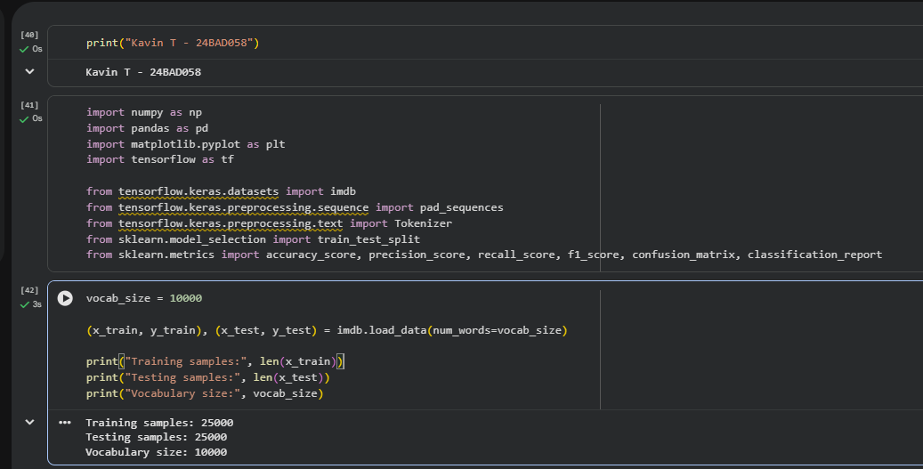

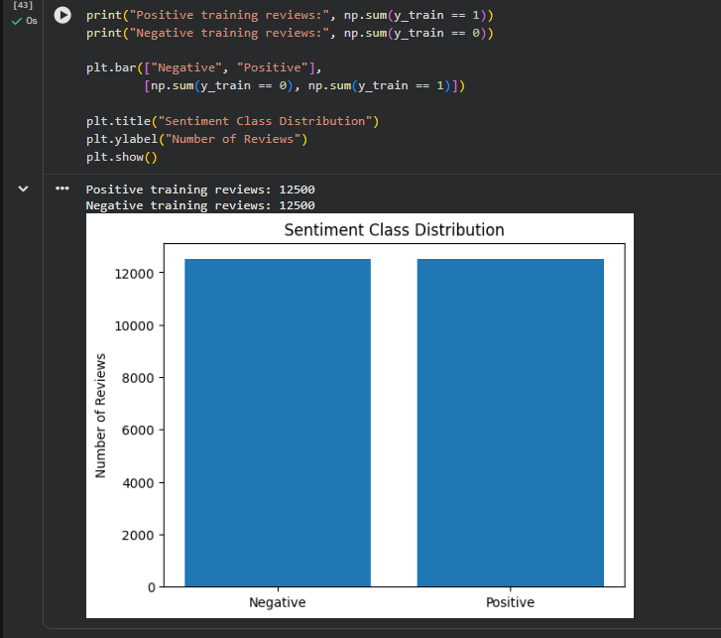

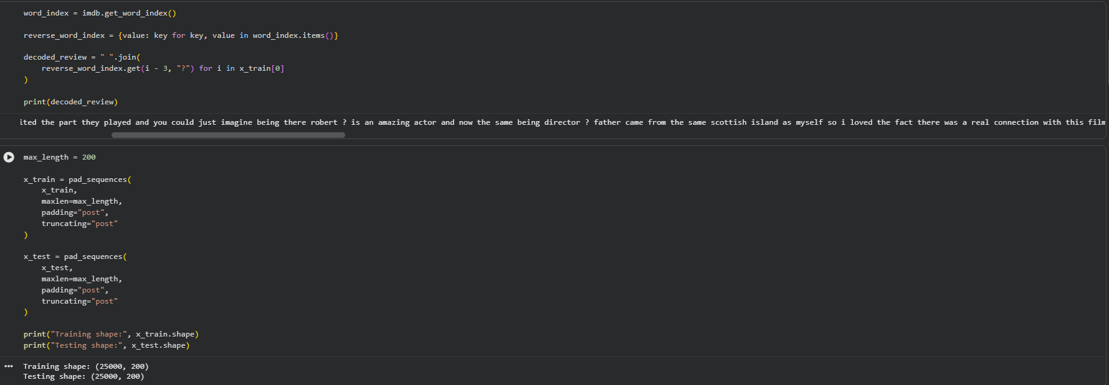
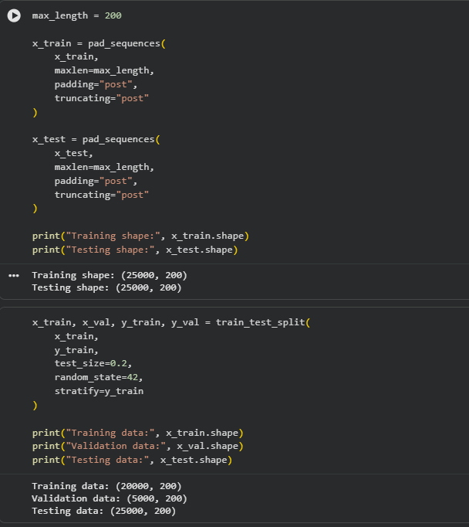

PART B: EMBEDDING GENERATION
Perform the following tasks:
- Generate numerical representations of the pre-processed text.
- Create an Embedding layer using Keras/TensorFlow.
- Define the vocabulary size and embedding dimension.
- Convert tokenized sequences into dense vector representations.
- Display the shape of the generated embedding representation.
- Analyze how words are represented in the embedding space.
(CODE: CONATAINS STUDENT ROLL NOS
SCREENSHOT OF CODE
SCREENSHOT OF OUTPUT)

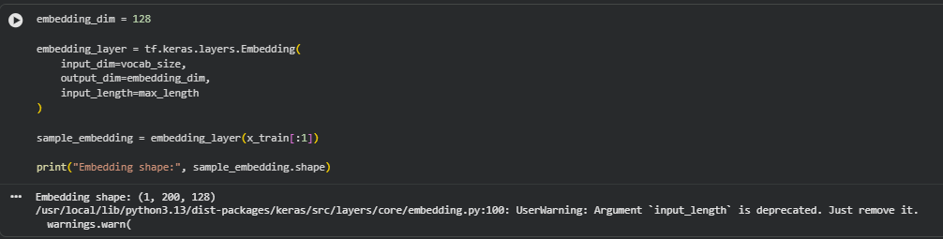

PART C: IMPLEMENTING THE LSTM MODEL
Perform the following tasks:
- Create an input layer for the padded text sequences.
- Add an Embedding layer to generate dense word representations.
- Add an LSTM layer to learn sequential dependencies in the reviews.
- Add a Dense output layer with an appropriate activation function for sentiment classification.
- Compile the model using:
  - Appropriate optimizer
  - Binary cross-entropy loss
  - Accuracy as the evaluation metric
- Display the model architecture and summary.
(CODE: CONATAINS STUDENT ROLL NOS
SCREENSHOT OF CODE
SCREENSHOT OF OUTPUT)

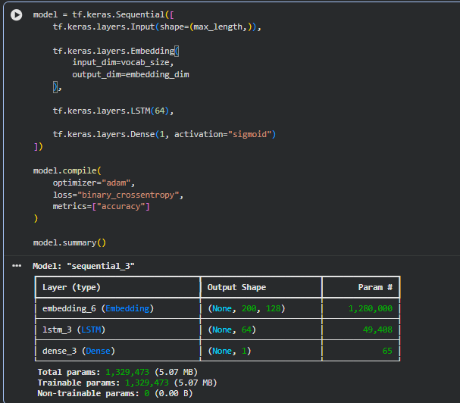

PART D: MODEL TRAINING AND SENTIMENT PREDICTION
Perform the following tasks:
- Train the LSTM model using the prepared training dataset.
- Validate the model using the validation dataset.
- Record:
  - Training accuracy
  - Validation accuracy
  - Training loss
  - Validation loss
- Visualize:
  - Accuracy vs. Epoch
  - Loss vs. Epoch
- Evaluate the trained model using the test dataset.
- Predict the sentiment of sample reviews.
- Compare the predicted sentiment with the actual sentiment.
- Calculate appropriate evaluation metrics such as:
  - Accuracy
  - Precision
  - Recall
  - F1-score
  - Confusion matrix
(CODE: CONATAINS STUDENT ROLL NOS
SCREENSHOT OF CODE
SCREENSHOT OF OUTPUT)

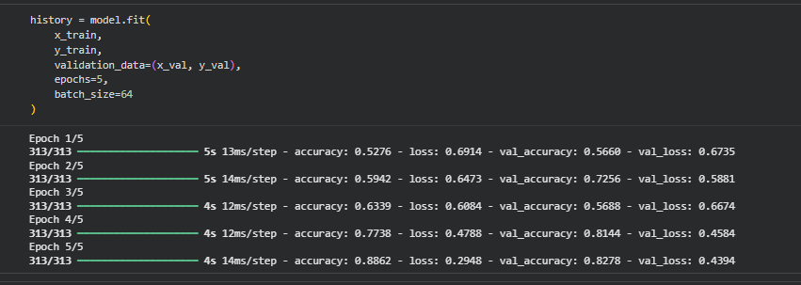
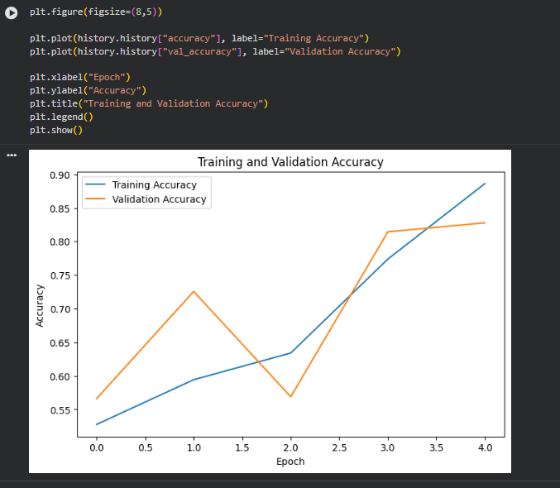
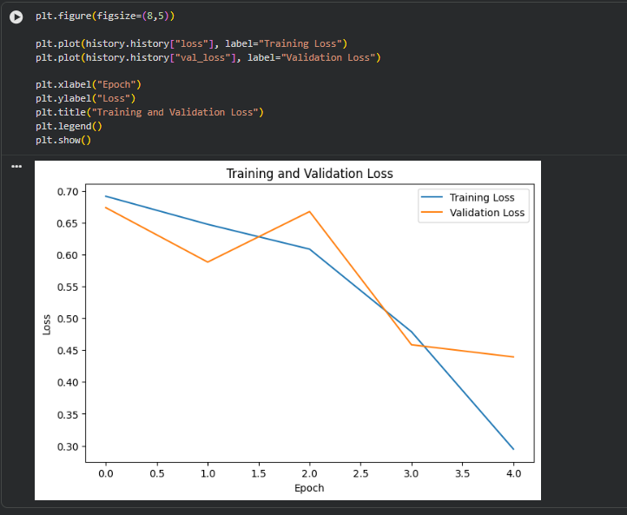

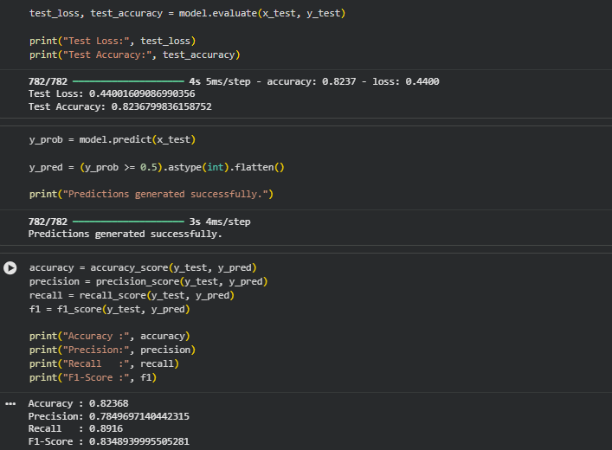

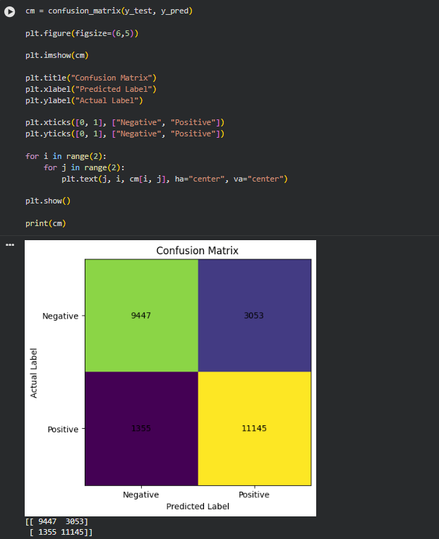

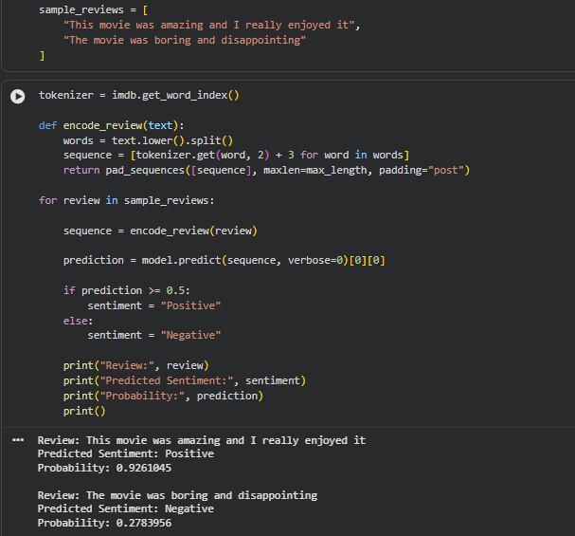

EXPECTED OUTCOME
Students will understand how LSTM networks learn sequential information from textual data and apply them to sentiment classification. Students will learn to perform text preprocessing, tokenization, sequence padding, and embedding generation using NLP libraries. They will build and train an LSTM model and evaluate its ability to classify reviews into positive and negative sentiments.

POST-LAB QUESTIONS (PROVIDE BRIEF ANSWERS TO THE FOLLOWING QUESTIONS)

- What is the role of the memory cell in an LSTM?

The memory cell stores important information from previous time steps. It allows the LSTM to carry useful information over long sequences and decide what information should be kept, updated, or removed.

- How does an LSTM overcome the vanishing gradient problem of a Simple RNN?

LSTM uses a cell state and gates (forget, input, and output gates) to control the flow of information. The cell state provides a better path for information and gradients to flow across many time steps, reducing the vanishing gradient problem.

- What is the purpose of the Embedding layer in the sentiment analysis model?

The Embedding layer converts words represented by integer/token IDs into dense numerical vectors. These vectors can learn meaningful relationships between words, helping the LSTM understand the sentiment of the text.

- How does padding affect the input to an LSTM network?

Padding makes all input sequences have the same length by adding zeros or special padding tokens to shorter sequences. This allows multiple text sequences to be processed together by the LSTM.

- What happens when the LSTM model is trained for too many epochs?

Training for too many epochs can cause overfitting. The model may perform very well on training data but perform poorly on unseen test data because it learns the training data too closely.

- Why are precision, recall, and F1-score useful in addition to accuracy?

Accuracy alone may not give a complete picture, especially when the classes are imbalanced.
Precision: Measures how many predicted positive results are actually positive.
Recall: Measures how many actual positive results are correctly identified.
F1-score: Combines precision and recall into a single measure.
These metrics provide a better understanding of the model's classification performance.

- Give one limitation of using LSTM for sentiment analysis.

One limitation is that LSTMs require more computational time and resources compared with simpler models because they have more parameters and process text sequentially.

SUGGESTIONS FOR DATASETS
- IMDB Movie Reviews – https://ai.stanford.edu/~amaas/data/sentiment/
- SST-2 (Stanford Sentiment Treebank) – https://huggingface.co/datasets/stanfordnlp/sst2
- Twitter Sentiment Analysis – https://www.kaggle.com/c/twitter-sentiment-analysis
- Stanford Sentiment Treebank (SST) – https://huggingface.co/datasets/stanfordnlp/sst
- Amazon Product Reviews – https://huggingface.co/datasets/amazon_polarity
- Yelp Polarity Reviews – https://huggingface.co/datasets/fancyzhx/yelp_polarity

ASSESSMENT
Description | Max Marks | Marks Awarded
Pre Lab Exercise | 5
In Lab Exercise | 10
Post Lab Exercise | 5
Viva | 10
Total | 30
Faculty Signature

